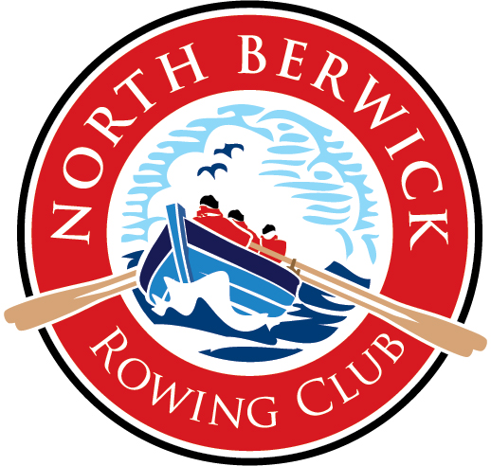

Regatta
27th August 2011

Welcome

N
orth Berwick Rowing Club was established in 2009, bringing traditional coastal rowing back to North Berwick

We are taking part in the Scottish Coastal Rowing Project, which involves first building boats in the community before using them to row recreationally and in competition. All of the boats being raced today are of the St Ayles skiff class. Four rowers power the craft from fixed seats, with a coxswain steering and co-ordinating the crew.
Scottish Coastal Rowing
http://scottishcoastalrowing.org/

Race Schedule
Boats will line up on start from West to East in the order listed below
Time | Event | Teams |  | Sponsored By
09:30 | Coxes Briefing - At harbour wall (next to Lobster Shack)
10:30 | Men 35+ | Portobello  Queensferry  Newhaven  Royal West  Anstruther  North Berwick  Cockenzie / Port Seton | Gilsland Caravan Park
11:15 | Women Open | Newhaven  Queensferry  Coigach  Portobello  North Berwick  Cockenzie / Port Seton  Portobello  Anstruther | Alice Stephenson  Optometrist
12:00 | Men 50+ | Queensferry  Coigach  North Berwick  North Berwick  Cockenzie / Port Seton  Portobello
12:45 | Women 50+ | North Berwick  Portobello  Dunbar  Anstruther  Cockenzie / Port Seton | Tyninghame Coffee Shop

Time | Event | Teams | Sponsored By
 | BREAK
14:00 | Men Open | Cockenzie/Port Seton  Portobello  Dunbar  Anstruther  Coigach  Newhaven  North Berwick  North Berwick  Portobello  Queensferry  Royal West
14:45 | Women 35+ | Portobello  North Berwick  Anstruther  Portobello  Cockenzie/Port Seton  Dunbar  Newhaven  Coigach  Cockenzie/Port Seton | 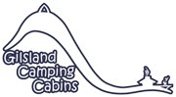
15:30 | Convenor's Cup | ELYC  Musselburgh  Newhaven  Gosforth  Dunbar
16:15 | Mixed Open | Cockenzie/Port Seton  Portobello  Dunbar  Newhaven  Portobello  Queensferry  Anstruther  North Berwick  Coigach  Cockenzie/Port Seton
18:00 | Prize Giving St Andrew / Blackadder. Church hall

Sunday Schedule
Time | Event
10:00 | Leisurely cruise
11:30 | Inaugural North Berwick Fishing Race / BBQ / Lunch

The Teams
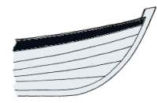 | 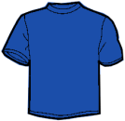 | Anstruther | 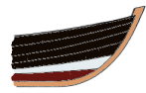 | 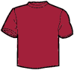 | Cockenzie/ Port Seton
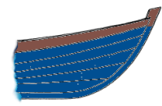 | 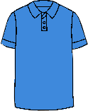 | Coigach | 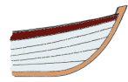
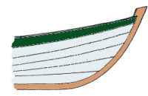 | 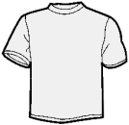 | Dunbar | 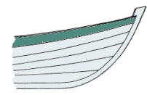 | 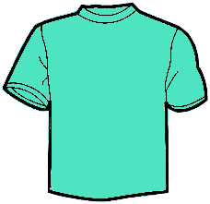 | Portobello
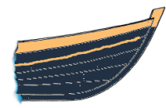 | 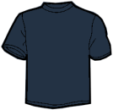 | Newhaven | 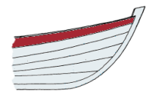 | 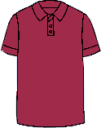 | Queensferry
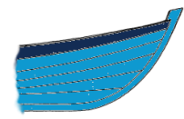 | 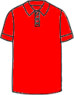 | North Berwick |  | 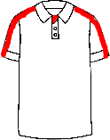 | Royal West

The Course
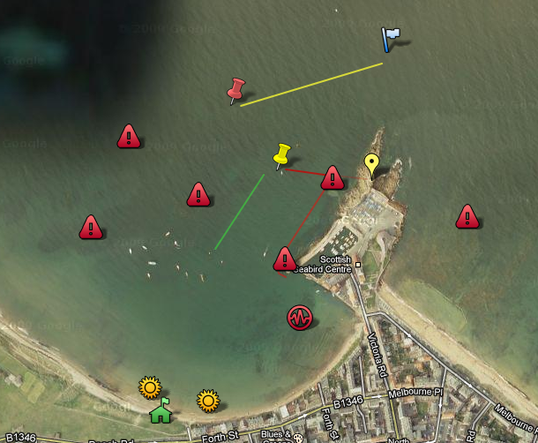
Boats will be racing today around Craigleith. The start and finish lines are a transit that will be explained to the Coxwains at the briefing. The course is just over 2 miles and will take the crews anything from 18 minutes to 25 minutes depending on conditions (of the crew and the water!).There are hazardous rocks in the West bay, marked on the image here.

Want to try rowing, just for fun, or competitively? Visit www.nbrowingclub.com for times of club sessions.

